**Current Work**

As a part of the visualization framework, we are also currently developing an additional layer that sits in between the data retrieval/analysis and the actual visualization. These visualization tools are often general purpose visualizations which take data in a specific format and turn it into something visual. But issues may arise as the data is not always in a format immediately usable by the visualization. The easiest way to fix this is to convert the data into a usable format. This requires a data conversion layer to be added to the visualization framework. In this layer, fields from the data are mapped to fields of the new format. These fields of the new format often translate directly to aspects of the visualization such as node size or colour, if we’re talking about a graph. This mapping can be conceptualized using a simple diagram where all the fields of the data are listed on the left and all the fields required by the visualization are listed on the right. Arrows are drawn from left to right represent the data mappings. Any given set of mappings for a particular dataset and visualization is called a “Visualization Strategy”.

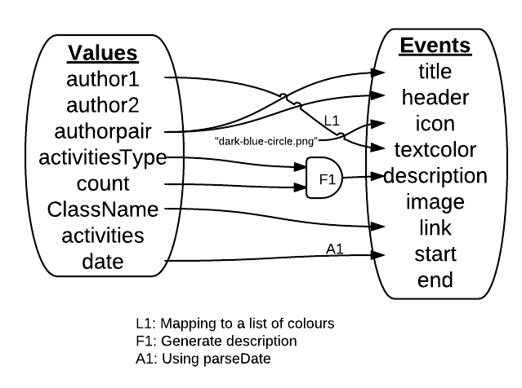

We are currently developing a system to take this visualization strategy and put it directly into the entire visualization framework. The advantage of this is its versatility, as any dataset can easily be adapted to work with any visualization; you just need a good visualization strategy. Also, because these strategies are easily designed and modified, this system lends itself to experimentation. This is useful, because when creating a visualization you often do not immediately know exactly how you want to map the data, and different strategies using the same data and visualization can sometimes produce very different results and reveal different patterns in the data.

**Future Work**

When creating a suite of many visualizations for the same data, there are often many things kept in common across all visualizations. These may include things like filters and legends. These commonalities are often closely related to how data is mapped to the visualization, so we plan on developing a system for creating dynamic filters and legends based on the visualization strategy.

Ultimately, we plan on building a visual tool for easily creating and maintaining visualization strategies. This will allow even non-programmers to experiment with data visualization.